- INTRODUCTION .
Modern social interaction can often be taxing and overwhelming, leading to social fatigue and isolation for many individuals. While AI chatbots have become common, most are purely transactional and "clinical," lacking the emotional depth and consistent personality required for true companionship. Furthermore, the reliance on cloud-based AI raises significant privacy concerns, as users are often hesitant to share personal thoughts with systems that transmit data to external servers.
This project introduces the "Multi-Personalized AI Agent Platform," a privacy-first web application that provides users with specialized AI companions that evolve locally. These agents use persistent behavioral prompts and real-time emotion detection to maintain a consistent persona that "remembers" and adapts to the user over time. By running entirely on the user's local hardware, it promotes a safe, judgment-free social proxy while ensuring total data sovereignty.

- PROBLEM STATEMENT.
The Multi-Personalized AI Agent Platform addresses the following critical limitations in current digital communication and AI systems:
  - Lack of Personal Behavioral Continuity
Most modern chatbots are "transactional" rather than "relational." They treat every conversation as a blank slate, failing to maintain a consistent persona or "remember" the user’s unique temperament, communication style, or history. Without Persistent Behavioral Prompts, the AI feels like a generic machine rather than a personalized companion that understands how to talk to you.
  - Social Barriers for Introverts
Many individuals, particularly introverts or those with social anxiety, find traditional human interaction taxing, judgmental, or overwhelming. Current AI interfaces are often too "clinical" or "form-based," failing to provide a non-judgmental social proxy. Users lack a safe, empathetic digital space where they can practice conversation and receive emotional support without the fatigue of real-world social cues.
  - Critical Privacy & Data Sovereignty Concerns
To achieve high levels of personalization, most AI services require users to upload sensitive personal thoughts and data to cloud-based servers (e.g., OpenAI, Google). This creates a massive privacy risk, as users are forced to choose between a "smart" assistant that logs their data or a "private" one that has no memory of who they are.
  - Absence of Emotional Intelligence (EQ)
Standard AI systems often miss the subtle emotional context of a conversation. They cannot dynamically adjust their tone, "temperature" (creativity), or verbosity based on the user's current mood. This results in "tone-deaf" responses that can feel dismissive or inappropriate during sensitive interactions.

- OBJECTIVES OF THE PROJECT
- To enable users to interact with “specialized AI agents” (e.g., Code Mentor, Emotional Support) through a private, localized interface.
- To provide a “real-time emotion detection” system that dynamically adjusts the AI’s tone and creativity based on user sentiment.
- To implement a “Self-Discovery Engine” that autonomously extracts and updates user personality traits from natural conversation.
- To ensure “100% data sovereignty” by executing all AI inference locally using the Ollama framework, preventing any data from leaving the device.
- To deliver a “premium, glassmorphic UI” that provides immersive visual feedback reflecting the AI’s emotional state.

- SCOPE OF THE PROJECT
  - In Scope
    - Multi-Agent Backend: A Node.js/Express server managing specialized system prompts and user session states.
    - Local AI Inference: Integration with Ollama for running high-parameter models (like Llama 3.1) locally.
    - Profile-Driven Memory: A MongoDB-backed system that stores evolving user profiles and conversation histories.
    - Emotion-Aware Frontend: A React-based UI that visually reflects the interaction state and provides seamless agent switching.

  - Out of Scope (Future Enhancements)
    - Mobile App Version: Development of a React Native application for mobile access.
    - Voice Integration: Implementing real-time Speech-to-Text (STT) and Text-to-Speech (TTS) for hands-free interaction.
    - Multi-Modal Support: Adding the ability for local agents to analyze images and documents.
    - Advanced Analytics: A dashboard for users to visualize their own emotional growth over long periods.

- Existing system
Currently, users seeking AI companionship or digital assistance rely on large, cloud-based Large Language Models (LLMs) such as ChatGPT, Claude, or Gemini. These systems operate using the following model:
- Cloud-Based Architecture: All processing happens on external servers, requiring constant internet connectivity.
- Transactional Memory: Most bots treat every chat session as a blank slate. Any "memory" or "personality" must be manually entered by the user every time.
- Generic Interaction: The AI provides the same tone and style of response to every user, regardless of their emotional state or long-term preferences.
- Static UI: Current interfaces are standard, row-based chat bubbles that do not change visually based on the conversation context.

- PROPOSED SYSTEM
The Proposed System is engineered to transcend the inherent limitations of the legacy framework by integrating a centralized, automated architecture that prioritizes long-term scalability and real-time data integrity. By leveraging modern computing paradigms—such as cloud-native microservices and distributed databases—the system aims to eliminate manual redundancies and significantly mitigate the risk of human error. This transition provides a seamless, high-performance interface that optimizes resource allocation, ensuring that the infrastructure remains resilient and highly responsive to evolving organizational demands and fluctuating data loads.
Building upon this foundation, the system introduces advanced synchronization protocols to ensure that all stakeholders interact with a "Single Source of Truth." This shift from a reactive to a proactive operational model is bolstered by a modular design, allowing for the rapid integration of emerging technologies without disrupting existing workflows. Consequently, the related outcomes include a substantial reduction in system latency, enhanced security through multi-factor authentication, and a robust framework for future-proofing the organization’s digital assets against technological obsolescence

  - Block Diagram
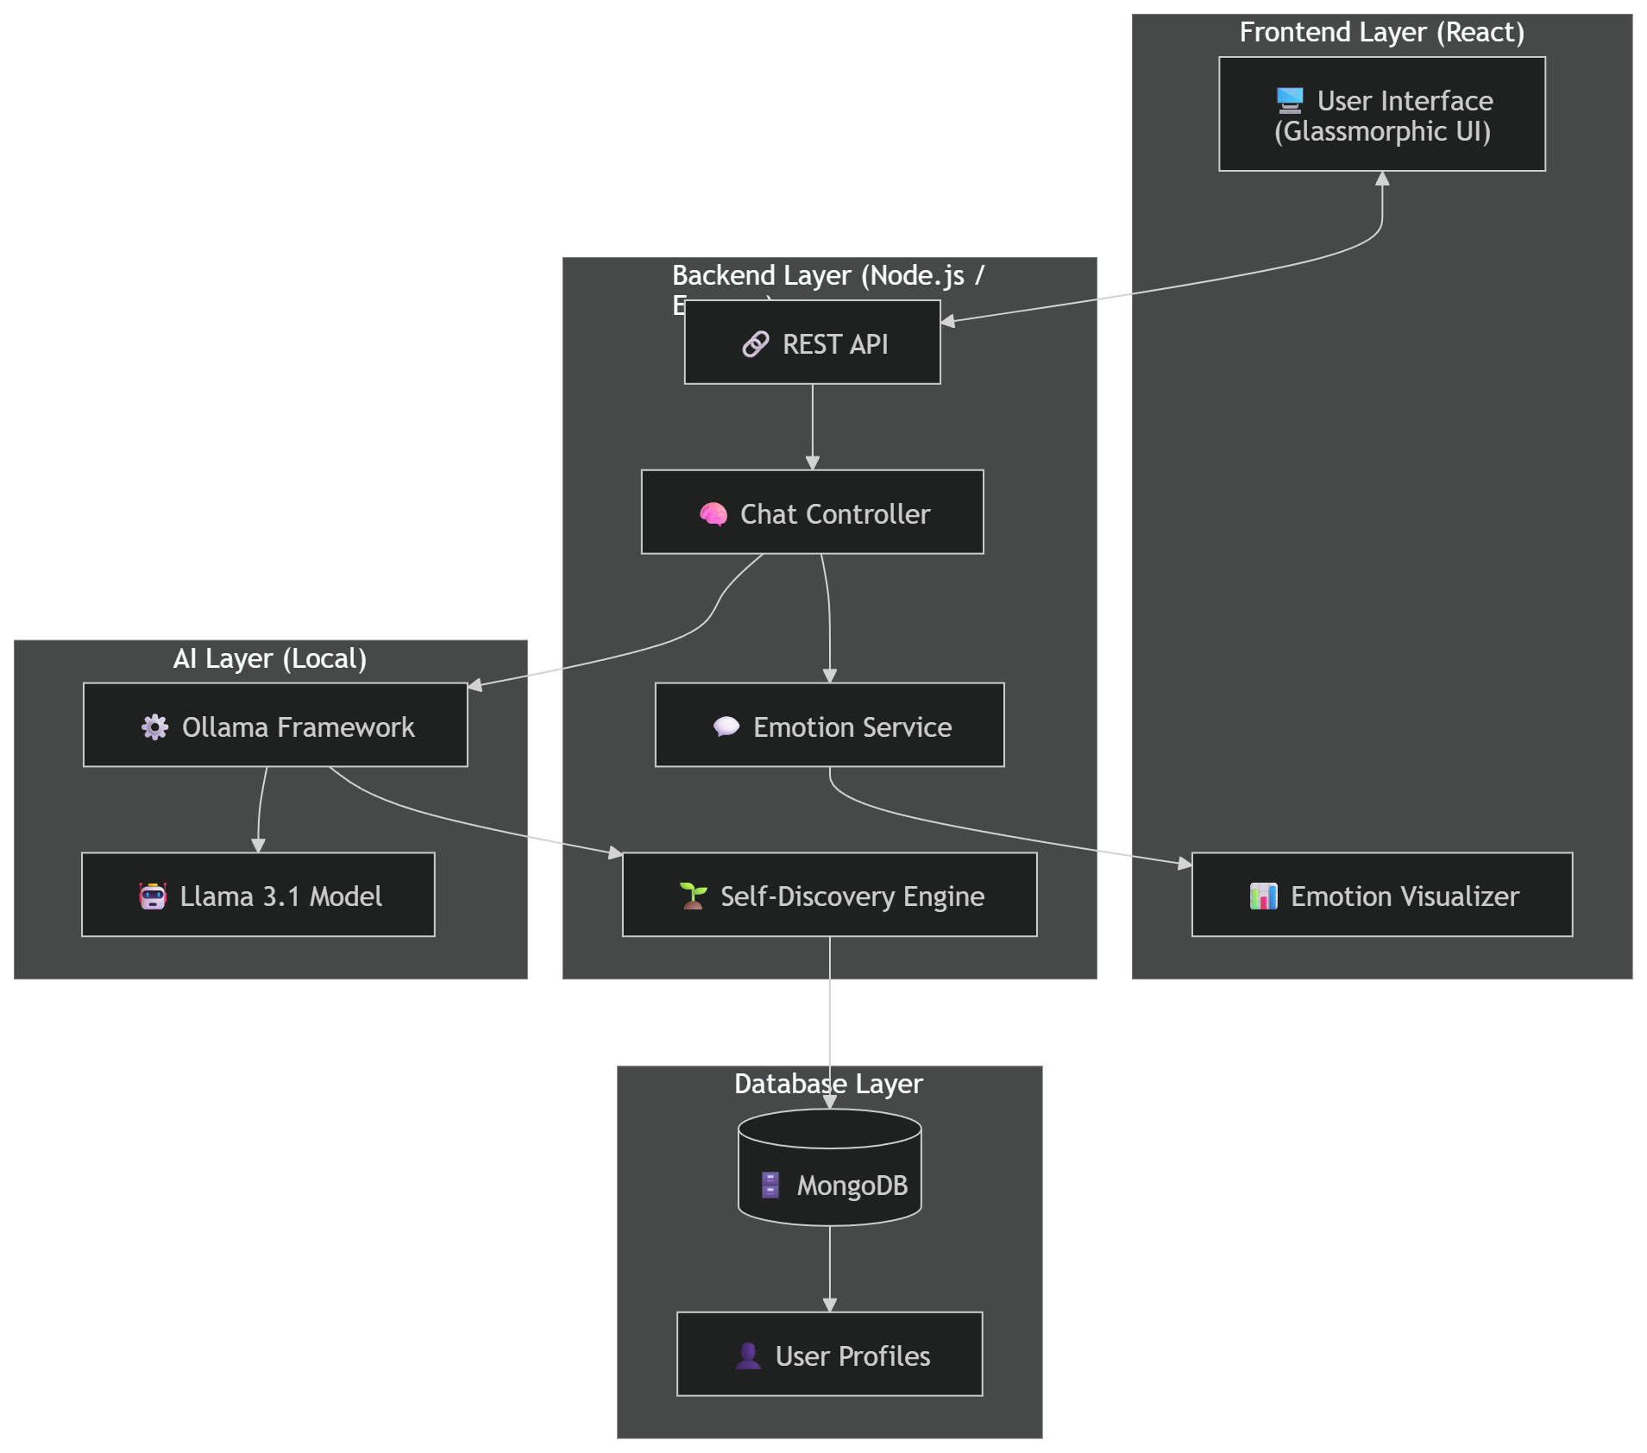

  - Flow Diagram
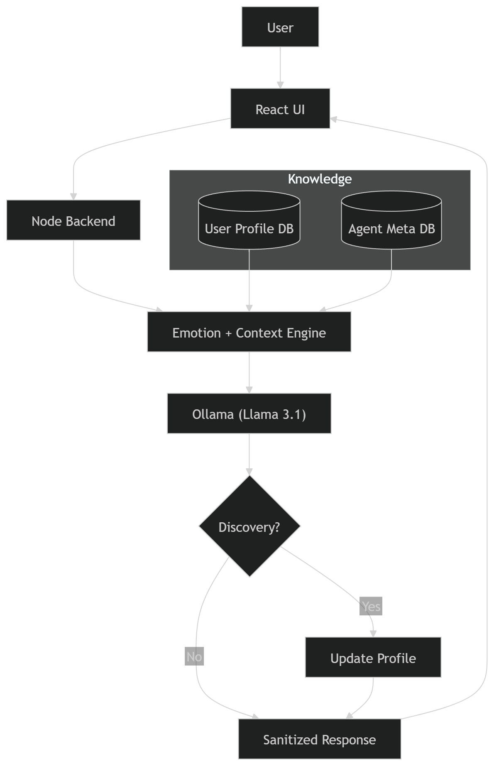

  - Input Output
In the Multi-Personalized AI Agent Platform, inputs and outputs are designed to facilitate not just information exchange, but emotional and behavioral growth.
    - Input Specifications
- The system captures three primary types of data from the user:
- Natural Language Text: The core conversational input provided by the user via the React interface (e.g., "I'm feeling really stressed about my project today").
- Agent Selection: The user chooses a specific persona for the interaction (e.g., Emotional Support for comfort or Code Mentor for technical guidance).
- Contextual Preferences: User-defined settings such as preferred response length (Concise, Balanced, or Detailed) and conversation tone.
    - Output Specifications
- The platform generates multi-layered outputs to provide an immersive experience:
- Persona-Consistent Text Responses: High-quality, empathetic text generated by the local Llama 3.1 model that aligns with the selected agent's unique behavioral guidelines.
- Real-Time Emotion Telemetry: Data visualization showing the detected emotional state (e.g., Joy, Sadness, Anger) and the confidence score of the analysis.
- Dynamic UI Feedback: Visual shifts in the interface, such as changes in the glassmorphic background colors and micro-animations that mirror the conversation's mood.
- Updated Profile Traits: Hidden data outputs that update the User’s Persistent Profile in MongoDB whenever a new interest or personality trait is "discovered" (e.g., adding "Enjoys hiking" to the database).
- Privacy Confirmation: Visual indicators ensuring that the connection is local and no data has been transmitted to the cloud.

- HARDWARE REQUIREMENTS
- Processor: Intel i7 / AMD Ryzen 7 or above (8-core processor recommended for local AI).
- RAM: 16 GB or above (Required to run high-parameter models like Llama 3.1 locally).
- Hard Disk: 20 GB free space (For application code and storing local AI weights).
- GPU: 4 GB VRAM recommended (NVIDIA RTX 20 series for faster response times).
- Display: Standard Monitor / Laptop.

- SOFTWARE REQUIREMENTS
- Operating System: Windows 10/11 / Linux / macOS.
- Frontend: React.js (Vite).
- Backend: Node.js / Express.js.
- AI Inference Engine: Ollama (Installed locally).
- Database: MongoDB (Local Community Server or Atlas).
- Core Libraries: Mongoose (DB Modeling), Axios (API), Lucide-React (Icons).
- Server: Node.js Runtime (Local Development Server).

- EXPECTED OUTCOMES
The successful implementation of the Multi-Personalized AI Agent Platform is expected to deliver the following results:
- Empathetic Digital Companionship: Users will experience a sense of emotional continuity as the AI agents "remember" and reference personal details, interests, and past conversations naturally.
- 100% Local Privacy (Zero-Data Leakage): Absolute data sovereignty where all AI "thinking" and personal history remain strictly on the user's local hardware, eliminating the risk of third-party data tracking.
- Adaptive Emotional Resonance: The system will successfully adjust its communication style (tone, verbosity, and temperature) in real-time, providing more supportive and appropriate responses based on the user's emotional state.
- Evolving "Self-Discovery" Profiles: An automated backend that builds a deep, multi-dimensional user profile over time without requiring manual input or static forms.
- Reduced Social Anxiety: Provision of a "Safe Social Proxy" where introverted users can practice communication and receive emotional support in a judgment-free, private environment.
- High-Performance Local Inference: Proving the feasibility of running high-parameter models like Llama 3.1 on consumer-grade hardware with responsive interaction speeds.
- Immersive Visual Feedback: A premium, responsive interface that provides visual cues (through color and animation) to mirror the psychological "mood" of the interaction.

- Limitations / Future Scope
  - Limitations
    - Hardware Sensitivity: Since all AI inference is performed locally, the application's performance (response speed and accuracy) is strictly dependent on the user's hardware (CPU, RAM, and GPU).
    - Emotion Accuracy: The current sentiment analysis service primarily uses keyword-based patterns, which may miss subtle nuances like deep sarcasm, regional slang, or complex emotional shifts.
    - Language Support: The platform is currently optimized for English language processing; multi-lingual support for evolving personalities is limited by the underlying local model's training data.
    - Cold Start Delay: On systems with lower RAM, there can be a slight delay (latency) during the initial loading of the Large Language Model when the application starts.
  - Future Scope
- Advanced Emotion Transformers: Moving from keyword-based analysis to deep semantic emotion detection using localized transformer models for 99% accuracy in sentiment recognition.
- Voice & Audio Integration: Implementing real-time Speech-to-Text (STT) and Text-to-Speech (TTS) capabilities to allow for natural, hands-free spoken conversations with the agents.
- Multi-Modal Intelligence: Enhancing agents with the ability to "see" and "read" by processing images and PDF documents locally, allowing them to discuss visual content and complex files.
- Cross-Device Synchronization: Developing a secure, encrypted peer-to-peer (P2P) sync mechanism to share the "Self-Discovery" user profile across multiple personal devices without ever using a central cloud server.
- Mobile Ecosystem: Expanding the platform into a dedicated mobile application (React Native) for empathetic companionship on the go.

- REFERENCES
- Ollama Team: "Ollama: Local Large Language Model Runner and API Documentation."
- Meta AI: "Llama 3.1: Technical Report and Model Card for Large Language Models," Meta Platforms, Inc. (2024).
- React Development Team: "React: A JavaScript Library for Building User Interfaces."
- OpenJS Foundation: "Node.js and Express: Minimalist Web Framework for Server-Side Logic."
- MongoDB, Inc.: "MongoDB Documentation: Schema Design and NoSQL Data Persistence."
- Vite Build Tool: "Vite: The Next Generation Frontend Tooling."
- Lucide Icons: "Lucide: Beautiful & Consistent Icon Toolkit for React."

